**ANALYZING CREDIT CARD APPLICATION APPROVALS**

Kunal Kolhe

112748535

**INTRODUCTION**

We are going to analyze what features cause a credit card application to be rejected. This will help us gain insight into the decision-making process that occurs when a bank approves or declines your credit application. Nowadays, this process is entirely automated with a credit card being approved within 10 minutes of you making an application. Credit score is calculated at the back end by the bank based on continuously updated data coming real time from all its users. Without visualizations like these, even the bank executives will be surprised at what data is considered and most relevant towards the decision.

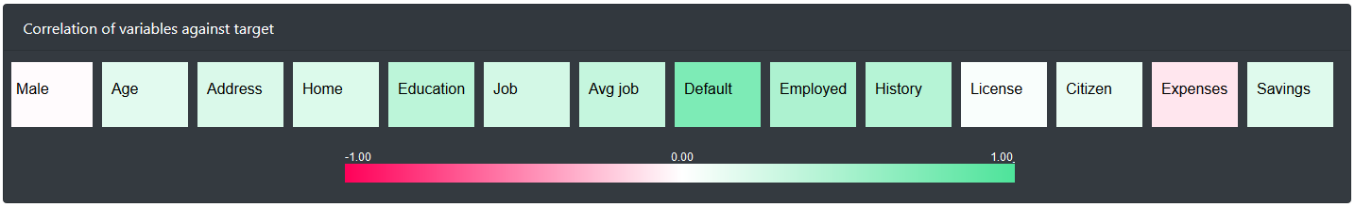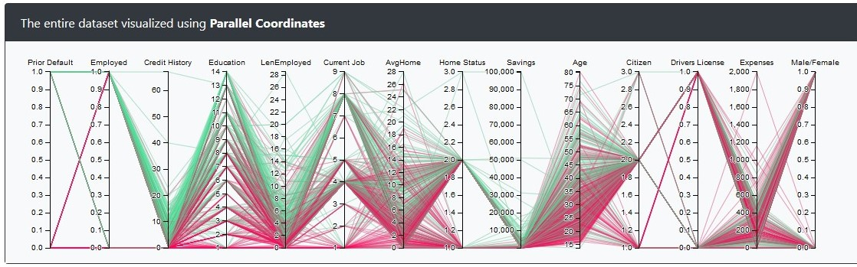

*Variables are sorted by order of most important*

Insights:

* A good track record of credit is important.
* The more educated you are, the better your chances are of being approved.
* A stable job is considered important while evaluation.

*Here You can see how each variable influences the outcome*

**Conclusion**

We identified the most important parameters while being considered for a credit card. We derived important and valuable insights which can be generalized to a certain extent for all applications. Based on such data, the bank can further fine tune approvals to mitigate risk on their behalf by setting the interest rate and credit limit of your new credit card.